Subject: Science. Worksheet 1 Date: 25.01.22
Chapter: Air and Water

I.Tick the correct answer

1. Air contains _____ which is needed for burning.
A) oxygen B) nitrogen C)sea water
2. Air contains 78 percentage of ______
A) Carbon dioxide B)nitrogen C)oxygen
3. Plants prepare their food with the help of________ gas
A) carbon dioxide B) nitrogen. C) oxygen
4. It is safe to drink water from
A)ponds B)rivers C)tubewells
5.The amount of water vapour in the atmosphere_______
A)Remains fixed B) Varies C) Is zero

II.Fill in the blanks

1. The amount of ______ in the atmosphere varies from place to place and from time to time.
2. Ozone absorbs harmful ______ rays of the Sun.
3. ________ is the first layer of the atmosphere where weather changes takes place.
4. _______ is the purest form of water.
5. __________ is the coldest layer of atmosphere

III. Match the following

S.NO | Column A | Column B
1. | Troposphere | purest form of water
2. | Disinfection of water | Weather changes
3. | Stratosphere | Settling of dirt
4. | Distilled water | ozone layer
5. | Sedimentation | Chlorination

IV. Answer the following questions

1. Define the atmosphere and name its various layers.
2. A burning candle kept inside a jar does not burn for a long time. Explain.

Subject: Science. Worksheet 2 Date: 25.01.22
Chapter: Air and Water

I.Mark the atmospheric layers and write their properties

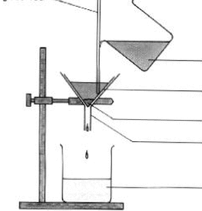
II. Name the method that is shown below for separating the insoluble substances from water and name it’s parts.

